**POLE BARNS &**

**ACCESSORY BUILDINGS**

LIVING AREAS IN POLE BARNS/ACCESSORY BUILDINGS

***BASIC CODE INFORMATION***



**CHRISTIAN COUNTY**

**RESOURCE MANAGEMENT**

Building Regulations Department

1106 W. Jackson St.

Ozark, MO 65721

Telephone: (417) 581-6064

Fax: (417) 275-6331

Revised February 14, 2021

***INTRODUCTION***

This information is based on the 2012 international one- and two-family dwellings code and other adopted Christian County amendments.

***This handout is only provided as a convenient source for basic information and does not address all the codes nor does the information take the place of any adopted code or amendments.***

This information simply acts as an instrument to better present and clarify some of the code interpretations and enforcement and does not represent the requirements for any building that falls under these occupancies; assembly, education, factory & industrial, high hazard, institutional, mercantile, residential, and these use groups; storage, utility and miscellaneous occupancies, where the buildings are not an accessory to one-and two-family dwellings and would not be classified as an agriculture structure.

***INSPECTIONS***

All inspections must be called in to the Christian County Building Regulations Department at (417) 581-6064 no later than the previous business day before 4:00 PM. If no answer, please leave a voicemail with permit number, address, contact name, phone number, type of inspection needed and date requested.

**Required Inspections: (also explained and list provided at permit issuance)**

**\*ON-SITE *FOOTINGS *FRAMING *FINAL**

*ADDITIONAL INSPECTIONS MAY BE REQUIRED WHEN ANY*

*OF THE FOLLOWING ARE INSTALLED*

* IN-GROUND PLUMBING * ELECTRICAL

* THICKENED SLABS/GRADE BEAMS * MECHANICAL

**ON-SITE:** The location of the structure, septic system, and property pins must be staked out on the property. The on-site inspection is required before any excavation.

**FOOTINGS/POST HOLES:** Commonly made after the excavation is completed. Post holes must be excavated with the required gravel in the bottom. Formed footings require the forms erected and required reinforcing steel in place prior to placement of concrete. If fill is used a compaction test and report may be necessary. Footings are to be dry (free of water and mud).

**IN-GROUND OR UNDERSLAB PLUMBING:** All joints and piping in place and visible prior to concrete. We will also look at any areas that need to have either thickened slabs/pads or grade beams for load bearing walls, required rebar will also need to be in place. Use caution when running plumbing in or through areas that may need thickened slabs. Depending on the area it may need anchor bolts installed in the concrete.

**ROUGH-IN:** Electrical, mechanical, and plumbing rough-ins need to be done along with all framing, fire-stopping, draft-stopping and bracing in place. This will need to be done prior to insulation and sheet rock installation.

**FINAL INSPECTION:** The building, yard grade, and all phases of construction must be complete. This inspection must be performed before occupancy or before any items are moved into the structure.

**It is the responsibility of the person and/or agent listed as the owner on the permit to obtain all the proper inspections. The failure to obtain the proper inspections will result in the uncovering of work or additional fees.**

The permit number is required to be posted and visible from the street/road at all times during the construction. Inspections will not be conducted if this information is not posted.

BUILDING PLANNING

***DESIGN LOADS:*** Roof Live Load……………………. 20 PSF

Ground Snow Load………………... 20 PSF

Wind Speed………………………... 90 MPH

Seismic Design Category………….. B

Soil Minimum Bearing Capacity….. 2,500 PSF

***ENGINEERING REQUIREMENTS:*** A Missouri licensed design professional is required to design the following:

* Other loads such as loft areas, hoist or other attached loads require a design for the footings/piers and structure.
* Any building pad that has fill material placed in it shall have a compaction test. The fill material is required to be engineered from the bottom of the fill to the top of the fill. Compaction tests are required to be submitted to Christian County Building Regulations with the application for the building permit.
* Any structure that has a width exceeding forty (40) feet or exceeds 5,000 square feet in area requires a designed set of plans. Plans are to indicate the footings, piers, column attachments, structure and design loads. Plans are to be submitted to Christian County Building Regulations with the application for the building permit.
* All wood trusses - Submit shop drawings and certifications.
* All metal structures - Submit a complete set of plans and shop drawings indicating footings, piers, thickened slabs/pads, column attachments, structure and design loads. Plans are to be submitted to Christian County Building Regulations with the application for the building permit.
* If post hole depths are shallower than what is required by the charts located in the document for minimum hole depths. *(located on page 6)*
* Any building that is not of typical post in-ground construction or standard stick-built construction or a combination of the two.

***POST:*** Wood post are required to be a minimum six-inch by six-inch (6”x 6”) ACQ or CCA treated. All others must be approved by the building official or engineer designed.

***EXITS:*** The distance from the egress door to the most remote area cannot exceed seventy-five (75) feet. Over seventy-five (75) feet will require two (2) or more egress doors located remotely from each other.

***ELECTRICAL REQUIREMENTS FOR BARN/ACCESSORY STRUCTURES:***Installed according to the adopted National Electric Code.

***HEATING-AIR CONDITIONING, PLUMBING and GAS SERVICE:***Installed according to the adopted International Codes.

POLE BARN STRUCTURES

FOOTING REQUIREMENTS

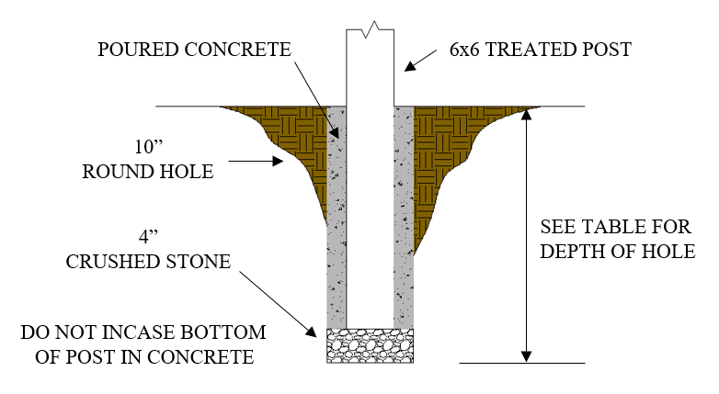**CONCRETE BACKFILL:** When the posts are placed in concrete the diameter of the hole is required to be ten (10) inches. The hole depth is set according to the tables located on page 6. The bottom of the hole is required to have four (4) inches of crushed stone placed under the post. **DO NOT PLACE CONCRETE UNDER THE POST.**

**SOIL BACKFILL:** When the posts are placed in soil the diameter of the hole is required to be twelve (12) inches. The hole depth is set according to the tables located on page 6. The bottom of the hole is required to have four (4) inches of crushed stone under the post. The soil placed around the pole is to be compacted.

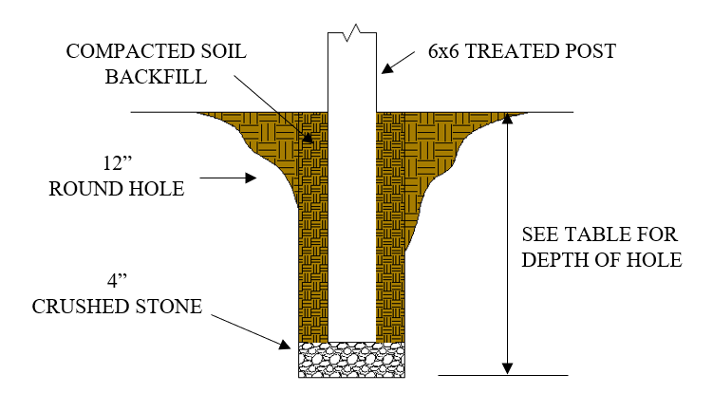

**POLES ARE REQUIRED TO BE A MINIMUM OF 6”X6” TREATED POST**

**POLES SPACED 8 FEET ON CENTER**

|  |  |  |  |  |  |  |  |  |  |  |
| --- | --- | --- | --- | --- | --- | --- | --- | --- | --- | --- |
| Maximum Clear Truss Span | Soil Backfill | | | | | Concrete Backfill | | | | |
| Eave Height From  Finish Grade | | | | | Eave Height From  Finish Grade | | | | |
| 8 ft. | 10 ft. | 12 ft. | 14 ft. | 16 ft. | 8 ft. | 10 ft. | 12 ft. | 14 ft. | 16 ft. |
| 20 ft. | 29" | 37" | 45" | 52" | 60" | 28" | 29" | 35" | 40" | 46" |
| 30 ft. | 32" | 40" | 47" | 54" | 61" | 28" | 31" | 36" | 41" | 47" |
| 40 ft. | 34" | 42" | 49" | 55" | 62" | 28" | 32" | 37" | 42" | 48" |

POST HOLE DEPTH CHART

**POLES SPACED 10 FEET ON CENTER**

POST HOLE DEPTH CHART

|  |  |  |  |  |  |  |  |  |  |  |
| --- | --- | --- | --- | --- | --- | --- | --- | --- | --- | --- |
| Maximum Clear Truss Span | Soil Backfill | | | | | Concrete Backfill | | | | |
| Eave Height From  Finish Grade | | | | | Eave Height From  Finish Grade | | | | |
| 8 ft. | 10 ft. | 12 ft. | 14 ft. | 16 ft. | 8 ft. | 10 ft. | 12 ft. | 14 ft. | 16 ft. |
| 20 ft. | 34" | 43" | 52" | 60" | 69" | 28" | 33" | 40" | 46" | 53" |
| 30 ft. | 37" | 46" | 54" | 62" | 70" | 29" | 35" | 42" | 48" | 55" |
| 40 ft. | 40" | 49" | 56" | 64" | 72" | 31" | 37" | 43" | 49" | 57" |

**Shallower pole depths or any eave height greater than 16’ must be engineered.**

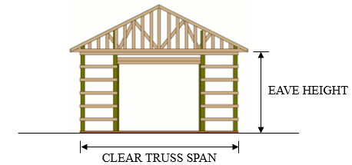

**TRUSS ATTACHMENT**

When the truss design requires the placement of a truss between the post, a ledger or rim is required. The ledger is to be a minimum of two (2) #2 grade, 2 x 10's. One placed on each side of the post as indicated in the examples below. The ledgers are to be attached to the post and the center support with two (2) 1/2" carriage bolts with washers and nuts. The trusses are required to be attached to the supports with one (1) 1/2" carriage bolt ***(See Detail B on the next page)***.

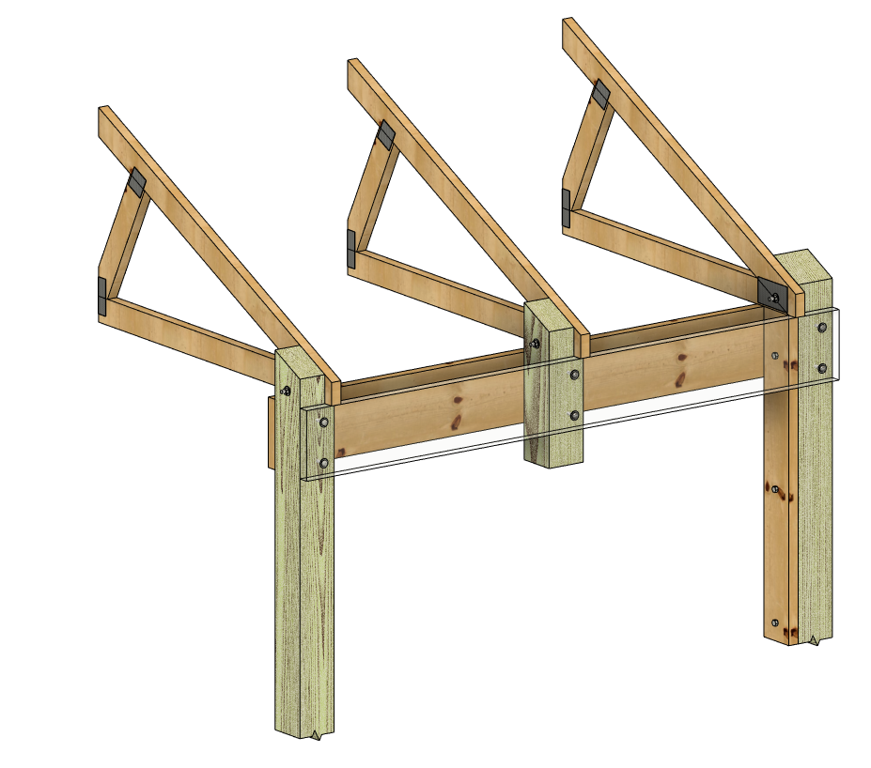

2 X 10 Ledgers Required

One Each Side Of Post

10’ Maximum

On Center

Post Spacing

Truss End

(1) ½” Carriage Bolt

With Nut And Washer

A Minimum 4’ Long 2 X 6

Attached Under Truss To

Post With (3) ½” By 5”

Long Lag Screw. Place (1)

A Maximum Of 6” From Each

End And (1) In The Middle.

(2) ½” Carriage Bolts

With Nut And Washer

Intermediate

Support Post

Engineered Stamped Trusses

Truss Attached

To Post

Truss Notched

1 ½” Into Post

6 x6 ACQ Or

CCA Treated Post

Trim top of post to

match angle of truss

**TRUSS ATTACHED TO EVERY POST**

**Truss Notched into Post:** The notch is to be no deeper than 1 ½” into the side of the post. The truss is to be attached to the post with one (1) 1/2" carriage bolt with washer and nut. A single # 2 grade 2 x 10 ledger or rim is required to be attached from post to post with two (2) 1/2" carriage bolts with washers and nuts *(****See Detail A****)*. That is unless there is an intermediate post attachment, if so, you will need two (2) #2 grade 2 x 10's instead (***See Detail B)***.

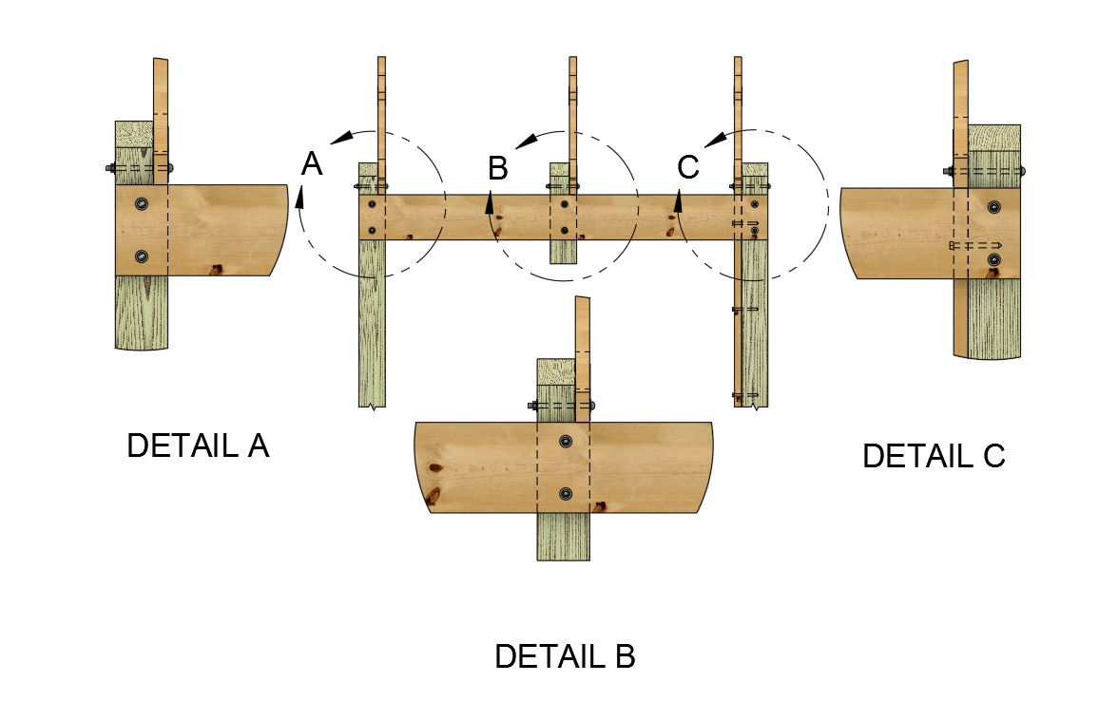

Detail A:

Truss notched into post.

The notch is to be no deeper

than 1 ½” into side of post.

The truss is to be attached to

the post with (1) ½” carriage

bolt with nut and washer.

Detail C:

Truss attached to post side.

The truss is to be attached to

the post with (1) ½” carriage

bolt with nut and washer. A

minimum 4’ long 2x6 is to be

attached under the truss to the

post with (3) ½” by 5” lag

screws spaced a maximum of

6” inches from each end and

(1) In the middle.

Detail B:

Intermediate post attachment.

Used when a truss is placed in

between full length post.

Use Detail A, to attach the truss.

The 6x6 post shall be

a minimum of 18” in length.

**Truss Attached to Post:** When the truss is attached on the side of every post the truss is to be attached with one (1) 1/2" carriage bolt with washer and nut. A #2 grade 2 x 10 ledger or rim is required to be attached from post to post with two (2) 1/2" carriage bolts with washers and nuts. A minimum four (4) foot long 2 x 6 is to be attached under the truss to the post with three (3) 1/2" by 5" lag screws spaced a maximum of 6" from each end and one (1) in the middle

***(See Detail C).***

All walls shall be braced and sheathed.

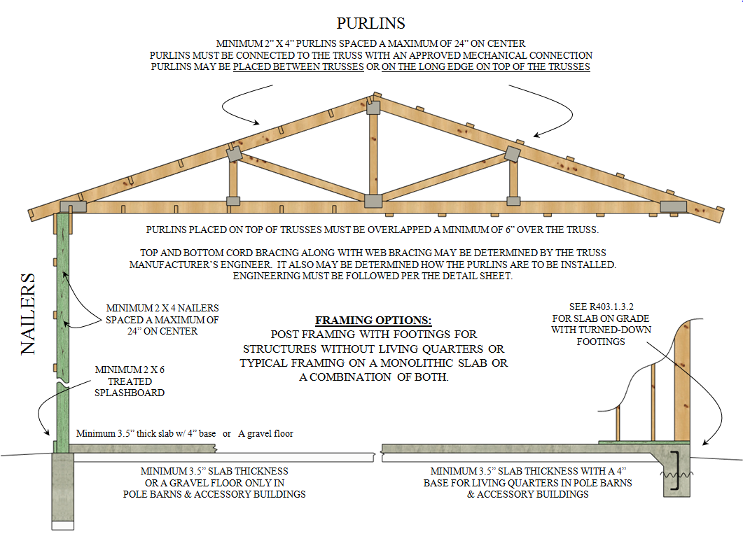

**Floors:** Pole Barns or Accessory Buildings ***without living quarters***, can either have a gravel floor surface or a poured concrete floor. If pouring a floor make sure that a 4" base course or approved subgrade is applied before the minimum 3.5" concrete is to be poured. The pour setup will have to be inspected if there is any below slab plumbing.

Pole Barns or Accessory Buildings ***with living quarters***, must comply with the adopted International One- and Two-Family Dwelling Code (See pages 15-16 for all requirements). A minimum 3.5" slab is required over a 4" thick base course. A 6-mil approved vapor retarder, is required to be placed between the concrete floor slab and base course. All under slab plumbing must be inspected and approved prior to pouring the slab.

**CONVENTIONAL CONSTRUCTION**

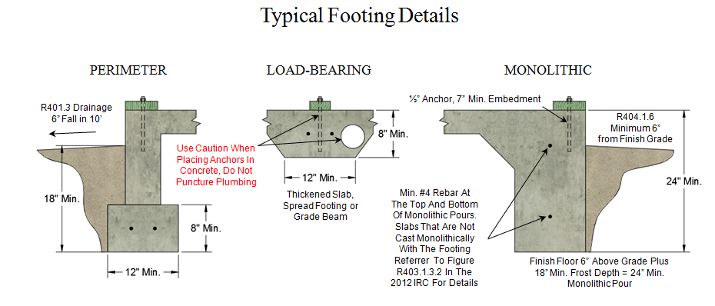The following diagrams and tables represent the requirements for construction using spread footings, rafters, and ceiling joist combination. These tables are not to be used with and engineered truss system and post frame construction.

**GIRDER AND HEADER SPANS FOR EXTERIOR BEARING WALLS**

|  |  |  |  |  |  |  |  |
| --- | --- | --- | --- | --- | --- | --- | --- |
| Girders and Headers Supporting | Size | Ground Snow Load (PSF) | | | | | |
| 30 | | | | | |
| Building Width (Feet) | | | | | |
| 20 | | 28 | | 36 | |
| Span | # Jack Studs | Span | # Jack Studs | Span | # Jack Studs |
| Roof and Ceiling | 2 - 2x4 | 3-6 | 1 | 3-2 | 1 | 2-10 | 1 |
| 2 - 2x6 | 5-5 | 1 | 4-8 | 1 | 4-2 | 1 |
| 2 - 2x8 | 6-10 | 1 | 5-11 | 2 | 5-4 | 2 |
| 2 - 2x10 | 8-5 | 2 | 7-3 | 2 | 6-6 | 2 |
| 2 - 2x12 | 9-9 | 2 | 8-5 | 2 | 7-6 | 2 |
| 3 - 2x8 | 8-4 | 1 | 7-5 | 1 | 6-8 | 1 |
| 3 - 2x10 | 10-6 | 1 | 9-1 | 2 | 8-2 | 2 |
| 3 - 2x12 | 12-2 | 2 | 10-7 | 2 | 9-5 | 2 |
| 4 - 2x8 | 9-2 | 1 | 8-4 | 1 | 7-8 | 1 |
| 4 - 2x10 | 11-8 | 1 | 10-6 | 1 | 9-5 | 2 |
| 4 - 2x12 | 14-1 | 1 | 12-2 | 2 | 10-11 | 2 |

[Ref. Excerpt of Table R502.5 (1) is from the 2012 International Residential Code]

**TABLE R802.5.1(1)**

RAFTER SPANS FOR COMMON LUMBER SPECIES

(Roof live load=20 psf, ceiling not attached to rafters, L/∆ = 180)



*(continued)*

**TABLE R802.5.1(1) --continued**

RAFTER SPANS FOR COMMON LUMBER SPECIES

(Roof live load=20 psf, ceiling not attached to rafters, L/∆ = 180)



Check sources for availability of lumber in lengths greater than 20 feet.

For SI: 1 inch = 25.4 mm, 1 foot = 304.8 mm, 1 pound per square foot = 0.0479 kPa.

a. The tabulated rafter spans assume that ceiling joists are located at the bottom of the attic space or that some other method of resisting the outward push of the rafters on the bearing walls, such as rafter ties, is provided at that location. When ceiling joists or rafter ties are located higher in the attic space, the rafter spans shall be multiplied by the factors given below:

|  |  |
| --- | --- |
| *HC/HR* | Rafter Span Adjustment Factor |
| 1/3 | .067 |
| 1/4 | .76 |
| 1/5 | .83 |
| 1/6 | .90 |
| 1/7.5 or less | 1.00 |

where:

*HC=* Height of ceiling joists or rafter ties measured vertically above the top of the rafter support walls.

*HR* = Height of roof ridge measured vertically above the top of the rafter support walls.

b. Span exceeds 26 feet in length.

[Ref. Table R802.5.1(1) is from the 2012 International Residential Code]

**TABLE R802.4(2)**

CEILING JOIST SPANS FOR COMMON LUMBER SPECIES

(Uninhabitable attics with limited storage, live load = 20 psf, L/∆ = 240)



*(continued)*

**TABLE R802.4(2) --continued**

CEILING JOIST SPANS FOR COMMON LUMBER SPECIES

(Uninhabitable attics with limited storage, live load = 20 psf, L/∆ = 240)

**

Check sources for availability of lumber in lengths greater than 20 feet.

For SI: 1 inch = 25.4 mm, 1 foot = 304.8 mm, 1 pound per square foot = 0.0479kPa.

a. Span exceeds 26 feet in length.

[Ref. Table R802.4(2) is from the 2012 International Residential Code]

***LIVING QUARTERS in BARNS/ ACCESORY***

***BUILDINGS***

Must comply with the adopted International One- and Two-Family Dwelling Code

and the following:

***FOOTING REQUIREMENTS***

* Footings are required to extend to the exterior wall side of the supporting post on a pole type structure. (SEE PAGE 17)
* Bottom of footing is required to be a minimum of eighteen (18) inches below finish grade.
* The top of the footing or foundation wall shall extend above grade; to where as the finish backfill or yard grade is a minimum of six (6) inches below the top of the finished floor level. (See illustration below)
* Footings shall be a minimum of twelve (12) inches wide by eight (8) inches thick with two (2) rows of #4 or ½ inch rebar in place before the concrete is poured. Rebar is to be supported a minimum of four (4) inches from the bottom of the footing, lapped and tied together.
* For the footing to be approved, it must be dry (free of water or mud).

***WALLS and CEILINGS***

* All interior walls shall be fastened to the concrete with an approved mechanical fastener spaced a maximum of six (6) feet on centers. **(POWER NAILING IS NOT ACCEPTED)**
* All walls on the interior of the exterior walls around the living area and the wall between the barn/accessory structure and living area are to be insulated and covered with approved wall covering from the floor to the ceiling or roof.
* The wall between the living area and the barn/accessory structure is required to be covered with a minimum of 1/2” gypsum board applied to the barn or garage side, it must continue to the bottom side of the roof and be flush unless a ceiling is installed with a minimum of 1/2" gypsum board.
* The area over the living area is required to be insulated.
* The ceiling of the living area is required to have a minimum of 1/2” gypsum board applied to the bottom of the ceiling.

***EGRESS***

* At least one (1) egress door must exit directly to the exterior of the living area. The required door shall be a side-hinged door not less than thirty-six (36) inches in width and six feet-eight inches (6’ 8”) in height.
* All egress doors are required to be opened from the egress side without the use of a key.
* All areas used for sleeping rooms must have one (1) direct egress to the exterior of the structure, either a window or door.
* Windows in a sleeping room shall be as follows:

* + - 1. The unit must be operable from the inside to a full clear opening without use of a key, tool, or special knowledge.
      2. The sill height is not to be more than 44 inches above the floor. This is measured from the finished floor to the bottom of the clear opening.
      3. The net clear opening requirement is to be obtained by normal operation of the window from the inside.
      4. Minimum net clear opening shall be 5.7 square feet or 820.8 square inches for windows located more than 44 inches above the finished grade adjacent to the window. Windows with the sill height 44 inches or less to the finished grade adjacent to the window shall be a minimum net clear opening of 5 square feet or 720 square inches.

***OPENINGS BETWEEN LIVING AREA AND BARN/ACCESSORY***

***STRUCTURE***

* No door or window can open into the sleeping area from the barn/accessory structure.
* A door from the barn/accessory structure opening into the living area *(not allowed in sleeping area*) must be a solid wood door a minimum of not less than 1 3/8 inch in thickness, solid or honeycomb steel door no less than 1 3/8-inch thickness or a 20- minute fire rated door. *Panel doors do not have the required rating or thickness.*
* Windows are not allowed between the living area and barn/accessory structure.

***SMOKE ALARMS***

* Required in all sleeping areas and outside of sleeping areas.
* Smoke alarms are required to receive their primary power source from the building wiring and have battery backup power.
* Smoke alarms are to be interconnected so all alarms will activate when one alarm is activated.

***ELECTRIC***

* Must comply with adopted National Electric Code.

***HEATING/AIR CONDITIONING, PLUMBING and GAS SERVICE*:**

* Must comply with the adopted International One- and Two-Family Building Code and Amendments.

***FOOTING FOR LIVING SPACE IN A POST FRAME STRUCTURE***

